

The Gaming Room

# **CS 230 Project Software Design Template**

Version 1.0

## Table of Contents

**CS 230 Project Software Design Template**1

**Table of Contents**2

**Document Revision History**2

**Executive Summary**3

**Design Constraints**3

**System Architecture View**3

**Domain Model**3

**Evaluation**3

**Recommendations**5

## Document Revision History

| Version | Date | Author | Comments |
| --- | --- | --- | --- |
| 1.0 | 01/23/21 | Alyssa Navarro | Working game, team and player classes  New class added – Entity class |
| 2.0 | 02/05/21 | Alyssa Navarro | Edited evaluation boxes |

.

## Executive Summary

This company has been experiencing challenges in developing a Lose It or Draw It game that works on multiple platforms. One of the common challenges is that the players were drawing images on an easel to help team members guess the puzzle. This led to the delay and less enjoyment of the game. With the rise in demand for mobile applications and web-based games, Creative Technology Solutions (CTS) has recently taken on a new client, The Gaming Room. CTS has decided to develop software where Lose It or Draw It games are used in different platforms. The Gaming Room will develop a web-based game that serves multiple platforms based on their current game, Draw It or Lose It, which is currently available in an Android app only.

## Design Constraints

Design phase is an important stage when developing an application. When developing web-based software, there are few design constraints that need to considered. The constraints for this project are the following:

* Language – Java
* Framework – API
* Database – in-memory data structures
* Timescale – 2 weeks
* Bugs – need to fix or find when testing

## Domain Model

The UML diagram below has seven classes, named;

* programDriver
* SingletonTester
* Entity
* gameService
* Game
* Team
* Player

Entity class is a parent interface where it relates to the four child classes. The child classes are: GameService, Game, Team and Player. GameService, Game, Team, and Player relates to each other in an association relationship where each entity depends the other one. The singletonTester class inherits from programDriver class which is the main class. The most object-oriented programming principle applied in this UML diagram is inheritance as mentioned earlier. It has enabled the singletonTester class to perform activities and responsibilities inherited form the main class.

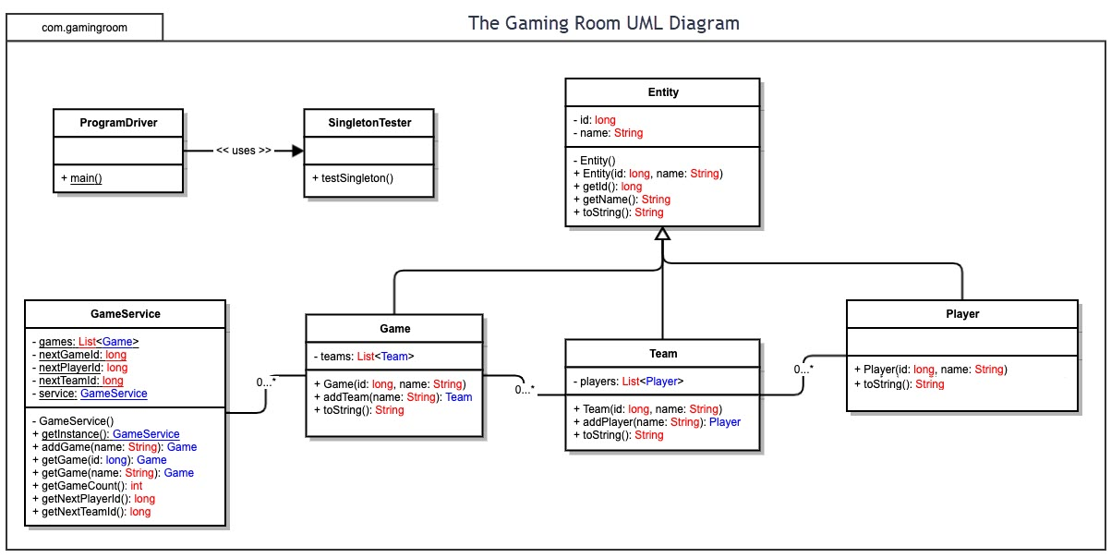

## 

## Evaluation

| **Development Requirements** | **Mac** | **Linux** | **Windows** | **Mobile Devices** |
| --- | --- | --- | --- | --- |
| **Server Side** | **Characteristics**  It is popular in web hosting  It is upgradeable  Flexible terminal commands | **Characteristics**  Secured, most preferred. | **Characteristics**  It is dominant to the other platforms.  Less loading time  easy virus susceptibility, poor technical support | **Characteristics**  More popular, high portability.  cost-effective |
| **Client Side** | It is expensive for the clients that are charged monthly.  Much time is required to access the software | Less loading time.  It is expensive as it’s not popular. | Less loading time.  It is expensive as more resources are required. | It is cost-effective  It takes less time to load a page |
| **Development Tools** | PHP programming language  JavaScript | PHP programming language | Java programming,  HTML/CSS  Netbeans | Android Studio, Android programming |

Recommendations

1. **Operating Platform**: Windows Operating platform is the recommended environment since it’s common in developing web-based software. It has less loading time and is relatively cheap. It is compatible and portable. Thus, making it suitable for the development of the Lose It or Draw It game.
2. **Operating Systems Architectures**: Windows has services used by all windows applications. This lets applications show a Graphical User Interface, or GUI, while using the resources and other applications on the device. The applications can include the graphics, messaging, and web services.
3. **Storage Management**: Database management system is the best storage system that will work effectively with Windows. It is easy to use and runs in multiple operating platforms. There can be extra disks to use for extra storage and that can enhance performance. This will allow the user to make the most out of the cloud.
4. **Memory Management**: To accommodate the heavy use from the Draw It or Lose It software, Windows applies memory compression technique. This will increase the responsiveness of the operating system. The game engine will allow us to utilize many libraries which are already built in. This saves time for us and avoids any hard coding.
5. **Distributed Systems and Networks**: Using LAN as the networking technology, the distributed system will use hubs to connect multiple computers. The hub will also serve as a repeater to amplify the signals that deteriorates when traveling for a long distance. Having LAN as our reliable network and Hub as the connectivity hardware, it will help the system to have a small outage overall. This will help with the cross-platform game that we are trying to make. A lot of users can use the game at the same time so it’s necessary to have a strong network.
6. **Security**: Windows has its own security software. But that doesn’t mean that it’s the best option for security. There are other companies out there that might have better security programs and will have better security measures. The software will help identify viruses or any malware in the programs.